INTRODUCTION

* 1. Overview

The speech and debate competition award certificate is an official document provided to the participant by higher management as a token of appreciation. These awards motivate non-participants to take part in such activities and get appreciated by other people for their talent and skills.

* 1. Purpose

Since a certificate is considered an appreciation, it motivates participants to perform better and better. It also encourages non-participants to take part in such activities. Certificates and awards make it possible to spread awareness about such competitions and their benefits to the young generation.

This reward boosts their morale and encourages them to achieve more in life. Students who get these rewards show them to others to prove their talent and skills. Furthermore, this award also boosts the confidence of the students.

PROBLEM DEFINITION & DESIGN THINIKING

2.1 Empathy map



2.2 Ideation & Brainstroming map

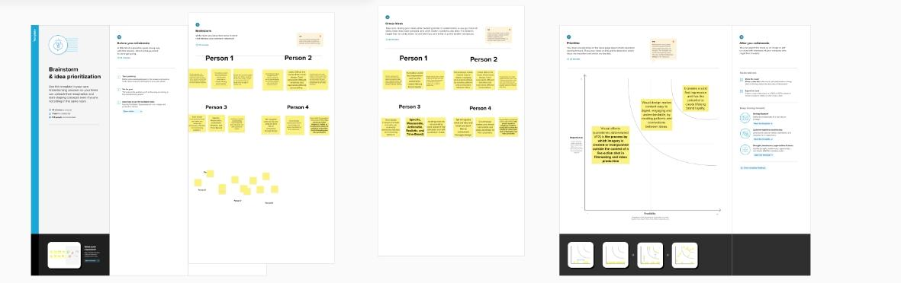

RESULT

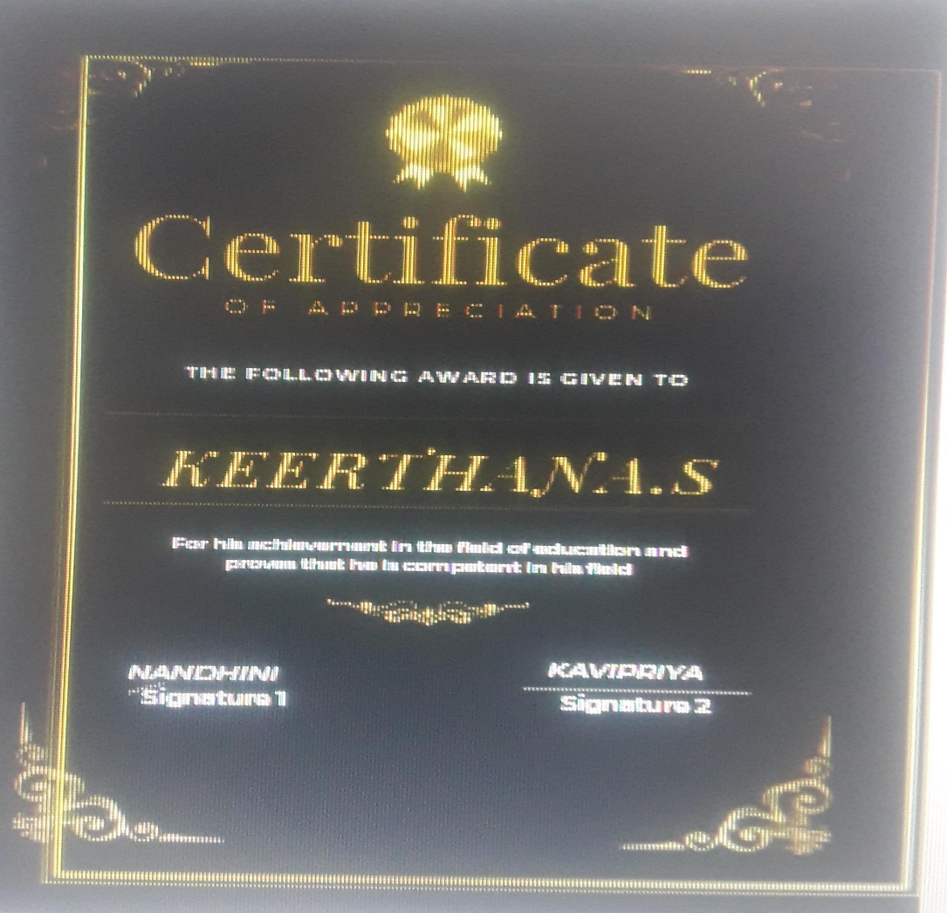

ADVANTAGES & DISADVANTAGES

### Advantages

* **Flexible Terms:** The terms and the amounts that can be deposited into a Certificate are flexible. If you are not willing to tie up your money for a long time, you can easily opt for a shorter term Certificate. At the end of a Certificate term, you can renew that Certificate or start a new one.
* **Safety:** Certificates that are available from a federally insured institution are generally insured up to $250,000. This takes much of the risk out of the investment.
* **Better Return Than Saving Accounts:** Since the Certificate holder is not allowed to withdraw money freely like savings account holders, Certificates are more valuable to the financial institution. For this reason, the interest rate offered to Certificate holders is higher than a traditional savings account.
* **Wide Selection:** You can get Certificates of various maturities and terms from different banks and credit unions. Because of the diversity of Certificates, investors can find a Certificate that meets their individual needs.
* **Fixed, Predictable Return:** The investor can be sure about getting a specific yield at a specific time. Even if the interest rates come down to a broader economy, the Certificate rate will remain constant. You will be able to easily determine the rate at which your balance will grow, thus making financial planning easier.

### Disadvantages

* **Limited Liquidity:**The owner of a Certificate cannot access their money as easily as a traditional savings account. To withdrawal money from a Certificate before the end of the term requires that a penalty has to be paid. This penalty can be in the form of lost interest or a principal penalty. To increase flexibility, the investor can create a Certificate Ladder, which is composed of Certificates with different maturity dates and terms. With a laddering strategy, you have more options to access your Certificate savings at different intervals of time.
* **Inflation Risk:** Certificate rates may be lower than the rate of inflation. This means that your money may lose its purchasing power over time if interest gains are outdone by inflation rates.

APPLICATIONS

I have used mural app and canva app.

CONCLUSION

We have created book cover with the help of canva.

FUTURE SCOPE

We were planning to join the graphic desingning course

